CREATE A MANAGED
TOURISM PROGRAM

September 18, 2018

Susan Guyette, Ph.D.
Santa Fe Planning & Research
sguyette@nets.com
(505)670-2577
www.susanguyette.com

Table of Contents

(Excerpts from Sustainable Cultural Tourism: Small-scale Solutions by Susan Guyette)
page
1. Introduction to Managed Tribal Tourism 1
2. Form, Scale, and Timing 3
3. A Regional Concept 4
4. The Tourism System 5
- Developing A Vacation Concept 7
- Increasing Economic Multipliers 8
- The Tourism Plan 10
- Conducting A Visitor Survey 11
- Creating Jobs 13
- Evaluating Success 16

1. INTRODUCTION TO A MANAGED TRIBAL TOURISM PROGRAM
Continuity of an idea through time by managing tourism takes people, time, and some resources. Benefits to the managed tourism approach include increased community gains and minimized cultural, economic, and ecological negative impacts. Tourism produces optimal benefits when a management structure coordinates or oversees all aspects of tourism—businesses, services, transportation, and activities.

IMPROVING THE TOURISM PROCESS
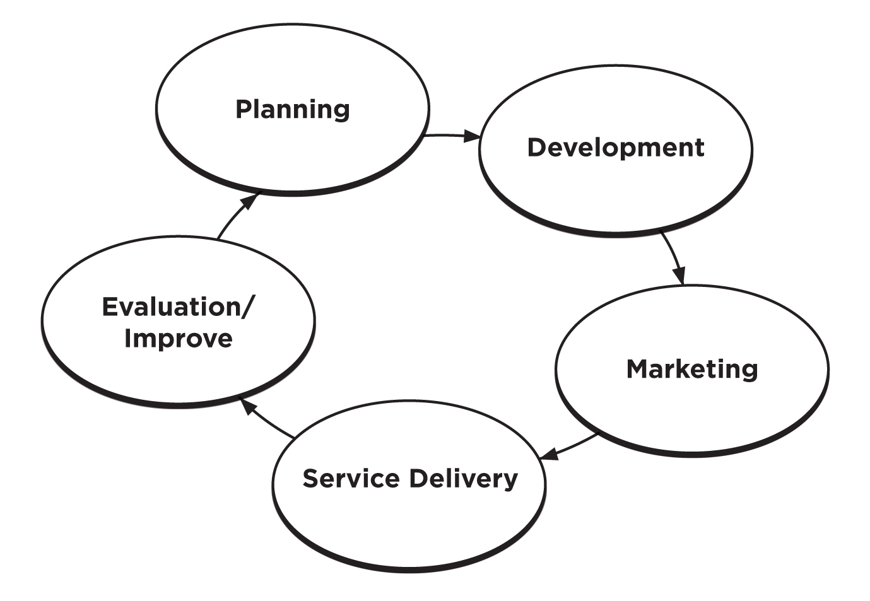

Managing tourism is a process that considers the suitable carrying capacity. Several types of carrying capacity affect cultural, economic, and ecological impacts:

- Physical capacity, or the number of tourists a place can physically accommodate;
- Environmental or ecological capacity, or the number of tourists that can be accommodated before damage is caused to the ecosystem;
- Social capacity, or the number of people a place can welcome, beyond which social disruption or irrevocable cultural damage will occur;
- Perceptual capacity, or the number of people a place can welcome before the quality of the tourist experience begins to be adversely affected; and
- Infrastructure capacity, or the number of tourists that can be accommodated by local infrastructure.

One frequent mistake made in tribal tourism development is lack of cohesion to the tourism network. Chambers of Commerce, Convention and Visitors Bureaus, and governments commonly create these networks in cities when tax revenues are available. Rural and tribal communities may not readily perceive the benefits of management and promotion or have the resources. In these communities, promotion frequently focuses on one or just a few larger businesses, not realizing that promotion inclusive of both small and larger-scale businesses creates a more cohesive vacation concept.
As tourism profits begin to be seen, a small share set aside to manage and promote tourism increases momentum. Some small villages, where monitoring entry is possible, designate a charge or a permit for entering into the community and fund tourism management with this income.
Another strategy is to reinvest a percentage of tax revenues for visitor surveys, assessing visitor satisfaction, promotion, visitor education, and future planning. This investment is a worthy outlay not only to grow the tourism market, but also to prevent negative impacts and increase community satisfaction with tourism.

Organizing for Increased Sustainability
The concept of linking smaller-scale enterprises and activities together into a larger, connected tourism itinerary relates well to sustainability. In review, organizing for tourism is a critical activity for:
- Assessing all services and activities potentially available to the visiting party;
- Creating a vacation concept;
- Protecting the regional environment;
- Designing itineraries, therefore extending length of stay;
- Projecting infrastructure needs, such as road improvements, water, solid waste (garbage) and sewage;
- Assuring the availability of food service, lodging, fuel, and adequate restrooms;
- Creating collaborative maps to guide visitors through a vacation;
- Collaborating for marketing to purchase advertising in publications with broader distribution; and
- Creating a welcoming atmosphere.

Regional organizing is useful for bringing a cohesive effort to tourism planning, management, impact assessment, and redirection. Otherwise, individual businesses tend to move forward alone, without forming an effective tourism network. The starting point is collaboration and defining a tourism strategy. Options include a tourism committee, tourism board, tourism association, or a Chamber of Commerce.
A gap in tourism services commonly occurs between the functions of planning and promotion. What occurs in between—business development, training in business management skills, assessment of success, and redirection—are the factors that sometimes fall between the cracks in a smaller community. Organizing to provide these services creates a support structure for businesses and entrepreneurs to thrive.
Whether bringing one community or several small communities together in a region, a managed vacation concept provides the comfortable experience for both community and visitor. Because tourism depends upon linkages, or creating enough services and activities to constitute a stop on the traveler’s route, a coordinated network is essential.
Small communities vary in their structure. In some, such as Native American tribes, government tends to own most of the businesses. Within this structure, coordination through a community tourism program is then more feasible than in communities where business ownership is primarily through the individual. For other communities, informal collaborations or Chambers of Commerce offer the capacity to provide promotion and training. One of the most effective ways of coordinating tourism is through a staffed position in a local government.
Financial support for a managed tourism program can be accomplished through:
- Grants, particularly for the start-up of enterprises or entrepreneurial and artist training;
- Revenues from tours, casino, stores
- Contracts for services
- % of tax revenues

2. FORM, SCALE, AND TIMING

Three variables—form, scale, and timing—are factors to guide a sustainable approach. When seen within the context of local values, community uniqueness becomes apparent.

Form

For tourism with a good cultural fit, new initiatives may be introduced while retaining forms of a rural or culturally traditional economy. For example, in many rural or reservation areas, small-scale cottage industries develop spontaneously by extended family units. Strengths of this business form are cooperation within the family, small-scale management, and flexibility of hours to allow for participation in traditional activities.
Barter is an example of a traditional economic form that increases resources for improved economic quality. Perception of economic success is gauged by quality-in-life rather than by absolute dollar amounts, the criterion generally used by funders of economic development projects. Success defined on a community’s own terms incorporates existing characteristics of form.
Other examples are:
- Enterprises based on traditional activities;
- Enterprises reflecting cultural values;
- Activities that are culturally unique and appropriate;
- Seasonally-appropriate cultural practices, such as celebrations;
- Enterprises reflecting conservation of natural resources;
- Family cooperation in making cultural items and cottage industry; and
- Co-operatives.

Scale

Appropriate scale increases the potential for success. Scale may be defined in relation to available capital, management expertise and lowered environmental impacts. For example, a series of small businesses networked together forms a larger-scale attraction. A series of small bed and breakfasts may be an appropriate scale, rather than a large motel or hotel for a community. Numerous, smaller businesses provide employment to local people, and require less complicated management skills.
Rapid and large development is a growth-oriented urban model, not based upon capacity-building. A central concept in my earlier planning texts is the option of two different ways to develop a large result. One is to plan larger-scale, secure financing, and import management staff experienced with larger-scale enterprises. The alternative is to plan smaller-scale enterprises and to link them together for a week-long vacation experience. Deciding on a local direction or “theme” for tourism, training local people in management, and linking together for promotional efforts, creates a larger concept from a network of locally managed, smaller enterprises.
Slower, gradual and linked development leads to a larger and more powerful outcome in terms of a solid community foundation. Examples include:
- Extended family or other forms of local organization recognized;
- Smaller, locally-owned enterprises begin to link;
- Growth capability incorporated as management capability increases;
- Infrastructure capability expanding without impacting resources for community;
- Limiting numbers of visitors prevents impacts on local ecosystems;
- Cultural practice not impacted negatively; and
- Seasonal flexibility accommodated.
Timing

The last variable, timing relates to building community capacity. When development is phased in stages—occurring when communities are receptive, infrastructure is in place, and capital is generated—readiness is better perceived. For example, some tourism-related businesses may start small and expand over time, as management capability is developed. These businesses are stronger and show a lower incidence of failure over the long term. Factors important to timing include:
- Assessing readiness;
- Developing gradually over time;
- Increasing internal capacity to manage;
- Promoting according to capacity to manage; and
- Assessing sustainable measures of progress and redirecting as necessary.

3. A REGIONAL APPROACH

When regional linkages constitute a journey and are seen as collaboration, a powerful tourism network is formed. A region is one context within which individual businesses may thrive. Unifying for planning purposes assists communities to develop complementary services.
Since visitors tend to spend several days and look for a variety of engaging activities and amenities, a connecting perspective is essential. Providing information— before arriving, during the visit, and after leaving—on how local resources are linked for the vacation experience, contributes to the comfort level of the visitor.
A region can be defined in different ways. Sometimes the term “region” is used to define a geographical grouping within a country, such as the Northeast or the Southwest. Another meaning of “region” is a part of a state, district or a province—emphasizing rural and urban communities—as well as ways of linking these areas together. When tourism entities define regions for a state, these delineations may not follow cultural, geographic, or activity similarities among communities. Rethinking primary alliances, yet working with the industry’s regional identification, will maximize options for tourism success.
A win/win urban and rural tourism network succeeds by raising overall visitor spending in a region. In a true partnership, both rural and urban communities realize a gain. Additionally, linked networks of small-scale businesses have the strongest resilience or adaptability in changing economic times.
FRAMEWORK FOR INTEGRATING CULTURE
- Identify communities with similarities, both cultural and geographic, to form a region.
- Identify business niches compatible with cultural values.
- Establish linkages with the tourism industry and communicate cultural values, unique situations, activities, and services.
- See the ways in which tourism can impart cultural understanding to potential partners.
- Create links between communities and form interesting itineraries, with interpretation.

By linking local offerings, the tourism draw is enhanced through additional opportunities for itineraries. Managing tourism according to sustainable criteria becomes easier when tourism seasons are extended with a range of activities and visitation numbers are more evenly distributed.

The Regional Tourism Concept
Community readiness for entry into tourism is critical to consider. A sudden tourism draw can be too much, too soon. For this reason, tourism planning at both the regional and community levels is important to determine community capacity and to identify steps for capacity-building.
Some communities do not want greater numbers of tourists—but rather additional expenditures from existing visitation. Increasing the number of visitors according to a growth model does not always correlate with more income directly for the host community. Guiding fewer visitors into a quality, small-scale, Native-owned experience brings the benefit to a region comprised of smaller communities.
Rather than readily adopting an industry perspective toward increased numbers of visitors, thinking through community intentions for tourism will produce the best cultural fit. Conducting assessments and developing a regional profile are starting points for becoming specific with marketing. Then, unique collaborations create a powerful tourism draw, as they form inviting vacation concepts.
The term “destination” is broadly defined as an area attracting non-local visitors. In rural areas, I repeatedly hear the term “destination” being used to describe a project idea. Originally defined as a region or a specific community, the term is now used to define a “destination resort,” with the goal of keeping tourist spending within the resort’s boundaries, including food service and boutique shops. Developers focused on larger-scale profits and negligent of ecological concerns tend to embrace this concept. The profits then accrue to a large corporation that operates the resort.
When this type of larger-scale development occurs, less income is gained in the local economy. For this reason, rural and culturally diverse communities benefit from tourism by pooling resources and developing regional entrepreneurial activity. Participation of organizations and cultural groups at the town, tribal, city, regional, statewide, national and international levels is valuable for both linking and promotional opportunities. Referrals are gained from such connections.

4. THE TOURISM SYSTEM
A systems approach to tourism planning considers both demand—in terms of market and characteristics—as well as supply, and the match between the two. Understanding these relationships with cultural sensitivity is at the core of planning locally. When tourism is desired, communities must be careful not to merely respond to an existing market for economic gain, otherwise negative socio-cultural and environmental impacts could be created. Sustainable development creates balances between cultural, economic, and environmental factors based on the strengths of all three in relation to local values, since values underlie motivation and actions.
Sustainable tourism recognizes interdependence within the tourism system. In this section the tourism system model developed by Clare Gunn¹ is adapted, expanding five functional components—attractions, services, transportation, promotion and visitor education—to include cultural considerations. Interrelatedness and cooperation between the components of a tourism system are seen as pivotal for success, perceived as the pleasant visitor experience.
Attractions are considered to be local cultural events, significant places, or locations that are planned and managed for visitor activity and enjoyment. These are the energizing elements of a tourism system, and strengthen the tourism draw by being clustered. Events, festivals, and markets are examples of smaller-impact, traditionally-based, and lower-cost visitor activities. Including small businesses and entrepreneurs creates the most authentic experience and the broadest earned livelihood benefit. Consistency in attractions and events from year-to-year is significant for interface with the tourism industry.
Cultural consideration: The word “attraction” may create a “cultural jar” implying commodification of traditional activities. Local design of visitor activities, based upon sensitivity to non-exploitation and communication of visitor etiquette, increases both visitor and local comfort with participation or observation. Demonstrations provide a way of limiting visitor access to privately held information, while imparting valuable basic knowledge about an art, history, or other visitor education topics. Not presenting a stereotyped image of cultures in the past—but rather a continuum from past, present, to future—is a new and informative trend of interest to cultural tourists.
Services are travel-oriented businesses such as accommodations, food service, travel agencies, gas stations, and other businesses serving basic and luxury traveler needs. They generate the greatest amount of jobs, income and tax revenues. Services derive from 1) independent ownership, 2) franchise chains, 3) quasi-governmental operations such as concessions, and 4) a non-profit or a non-governmental organization (NGO). The smaller community tends to benefit primarily from independent ownership and non-profit forms. For example, concessions in parks rarely purchase locally, and franchises generally compete with “Mom and Pop” businesses, leading to local closures. Given these trends, the visitor must be able to find locally-owned service businesses easily.
Cultural consideration: Service ideas defined from local traditions reflect authenticity and local values. Friendly businesses, based upon extended family cooperation and making the effort to sell locally hand-made items in addition to services, maximize the number of culturally-based jobs. Referrals from one service-oriented business to another reflect cooperation rather than competition and further overall community goals. Services clustered geographically tend to reduce negative environmental impacts.
Transportation considered on a regional basis is conventionally defined as the means of getting the visitor to a destination. Air travel, boat, car rental, bus, mini-vans, and pedestrian routes are modal alternatives. Inter-modal connections are increasing every year, as reducing the carbon foot print of tourism comes to the forefront.
Some traditional communities lower ecological and cultural privacy impacts by allowing only mini-van transportation to their lands. Good examples of managed tourism utilizing limited access mini-van transport are two Native communities—Saxman in Alaska, USA (www.capefoxtours.com/saxman.html) and Acoma Pueblo in New Mexico, USA ( www.acomaskycity.org).
Effective signage relates to visitor comfort and guiding visitors to locally-owned businesses. Preventing the lost visitor from wandering into residential and ecologically fragile areas by guiding them to the appropriate areas is valuable for avoiding negative environmental impacts. Hostile, “Keep Out” signs drive visitors away by creating an unfriendly atmosphere. “No visitors beyond this point. Please respect our land and culture” is a possible alternative expression.
Cultural consideration: How destinations are considered affects equitable returns to a great extent. Small-scale transport by mini-van reduces environmental impacts compared to large buses. Stops along the way to locally-owned businesses create entrepreneurial jobs. Large resorts are fond of providing the transport from the airport, driving through small communities without stops, thereby encouraging all expenditures directly to the resort. Local transport can structure itineraries to include multiple stops.
Information provides basic guidance to visitors and is different from promotion. A visitor center or an intake point, such as a museum, are focal places for visitor orientation. Information basics for a respectful and safe visit include: weather conditions and needed clothing; etiquette (e.g., customs, taboos, privacy restrictions, areas off limit); local foods; physical demands; maps; itineraries; and health information (e.g., nearest local services, incidences of giardia or lyme-bearing ticks, or water dangers).
Cultural consideration: Hospitality training blending tourism management practices with local cultural hospitality and values for relating to visitors will produce the unique welcoming. Information then becomes attractive in style as well as content. Specific information on locally-made items and foods creates local job creation and support of cultural entrepreneurs. A business directory listing specifics on locally-owned businesses and entrepreneurs becomes essential for encouraging expenditures.
Promotion targets market segments and creates a visitation draw. Both hardcopy (brochures, maps, visitor guides) and internet promotion reach potential travelers as they plan vacations, and for guidance on the needed elements for their trip. Use of social networking (Facebook, LinkedIn, YouTube, Twitter, and those tools yet to come along) is becoming a prevalent and low-cost way to promote. Publicity may be available at no cost (articles in magazines, newspapers, and online sources), whereas advertising, public relations efforts, and incentives (gifts and discounts) require cash outlay.
Targeted promotion expands visitor awareness of offerings, encourages authenticity, and increases the market draw. Avoiding generalized promotion by providing specifics on attractions, events, and basic services benefits the community directly. Locator maps are essential for guiding visitors directly to local businesses.
Cultural consideration: If a community decides upon its own historical and cultural interpretation, then cultural understanding is furthered, along with cultural pride. A positive presentation aligns visitors, and if customer service matches the messages put forth in promotion, the majority of visitors will go out of their way to purchase in local businesses and will tend to donate to cultural teaching efforts.
A fully developed tourism system on the community or regional scale is the key to both visitor and community satisfaction in the tourism equation. Addressing these elements minimizes negative impacts and maximizes positive gains, according to definitions from within.

- DEVELOPING A VACATION CONCEPT
Once complementary network strengths are understood, itineraries are possible to develop that link together specific attractions, service businesses, and transportation to form vacation concepts. Unlike city stays, where visitors assemble their own itineraries from hundreds of choices, the rural stay requires enough activities to constitute a draw.

Determining the Effective Links

Meeting a balance of visitor interests constitutes the most innovative combination of links. Examine statewide and regional visitor surveys closely during the planning process as a guide to potential tourism niches. For example, understanding whether a community’s visitors are more attracted to recreational opportunities or shopping, is important to foster successful enterprise development.
Look for natural connections, such as historical trade routes, cultural art tours, or combinations of cultural and scenic beauty points of interest. Once these connections are identified, tapping into a combination of resources—such as economic development and arts programs for teaching, interpretation, enterprise development, and marketing—increases the long-term stability of a tourism effort. Long-term commitment to a viable idea, coupled with cultural and ecosystem restoration, correlates well with sustainability.

Connecting the Links into Itineraries
The tourism draw to an area depends upon the variety of available activities and how well they are linked. Highlighting the uniqueness of a region historically, culturally, and ecologically is possible through interpretation and informative marketing. Once a tourism resource inventory or a plan is completed, then link complementary activities, services and enterprises into appealing vacation itineraries is possible.
Visitors prefer more than one itinerary option—such as educational, shopping, and recreational-oriented visits. Multiple-day visits are encouraged with several itineraries. Effective itineraries include:
- Attractions
- Services
- Educational opportunities
- Local ecosystems
- Tours
- Driving times
- Transportation options
- A map linking offerings
- A calendar of events
Emphasizing smaller-scale businesses, such as bed and breakfast lodging and smaller restaurants featuring local foods creates the itinerary of greatest local benefit.
A local community is best prepared to provide accurate and fascinating interpretation. Conveyance of a message through a vacation itinerary motivates and excites the visitor for a journey to a specific location. This message is created by identifying “out-of-the ordinary” activities, unique foods, restful lodging, places of scenic beauty—and interpreting them in relation to the message. Tools for interpretation are visitor guides, brochures, and websites, or if on a low budget, a simple photo copied flier.
The vacation perceived as a struggle to find services and activities repels visitors. Either they don’t return for a repeat visit or leave the region early in search of a more interesting or scenic experience. Since word-of-mouth referrals are an extremely effective way of advertising, the experiential vacation requires excellent customer service. The attraction to small-scale links, whether rural or urban, increases the visitor’s ability to connect with local people and learn about local cultures or other ways of viewing the world, foods, and local history.

- INCREASING ECONOMIC MULTIPLIERS
Small communities lacking a broad range of services experience a high level of economic leakages outside of their local economy. Economic leakages occur when dollars are spent outside of local economies due to the lack of services within a region. An economic multiplier is the number of times a dollar is re-circulated in a local economy. When leakages occur, the economic multiplier is small. The higher an economic multiplier, the stronger the economic base within a small economy. Regional linkages providing referrals increase a multiplier effect.
There are two markets to consider in tourism, the internal community and those outside of the community or region. Tourism may bring a large enough supplemental market to a small community to justify basic services such as gas stations, convenience stores, laundromats, grocery stores, and clothing stores. Combining external and internal markets therefore brings increased benefits to a community. Additionally, service-oriented businesses tend to generate the highest multiplier effects from tourism.
Visitor purchases plus local purchases hold the potential of a sustainable market for an enterprise.

Frequently, rural communities do not realize what treasures their local culture and local economy are in the visitor’s eye. These are a part of local everyday life. Yet, a satisfying experience to the visitor is the everyday, the authentic. Assistance from outside of the community may be useful in pinpointing these unique local strengths.
As an example, bed and breakfast lodging operations offer potential for the rural farm house or empty nest family. Staying with a family gives personal connection to the area, an opportunity for local interpretation and guidance to other links in the tourism network. Farm stays present fascinating experiences for travelers, and hold the potential for generating enough additional income to sustain the farm. Whether information about the farm or a u-pick-em experience is provided, “value-added” is perceived with the lodging experience. Link farm stays, and a fascinating itinerary is created. In Europe, considerable governmental assistance to farm stays has resulted in less farm land lost to development, in addition to a linked referral system.
Diversification is the key to creating economic multipliers. Balancing larger-scale with small-scale industries creates additional employment niches and encourages small supplier enterprises for larger businesses. Additionally, developing opportunities for cultural entrepreneurs works well with cooperative and extended family-based cultural values. For these reasons, it is beneficial to encourage a complementary approach to economic development. When all businesses in a region see themselves working toward a common tourism goal, a linkage is formed to encourage cooperation for other community needs. The creation of a cohesive community or region may become a long-term economic development outcome.
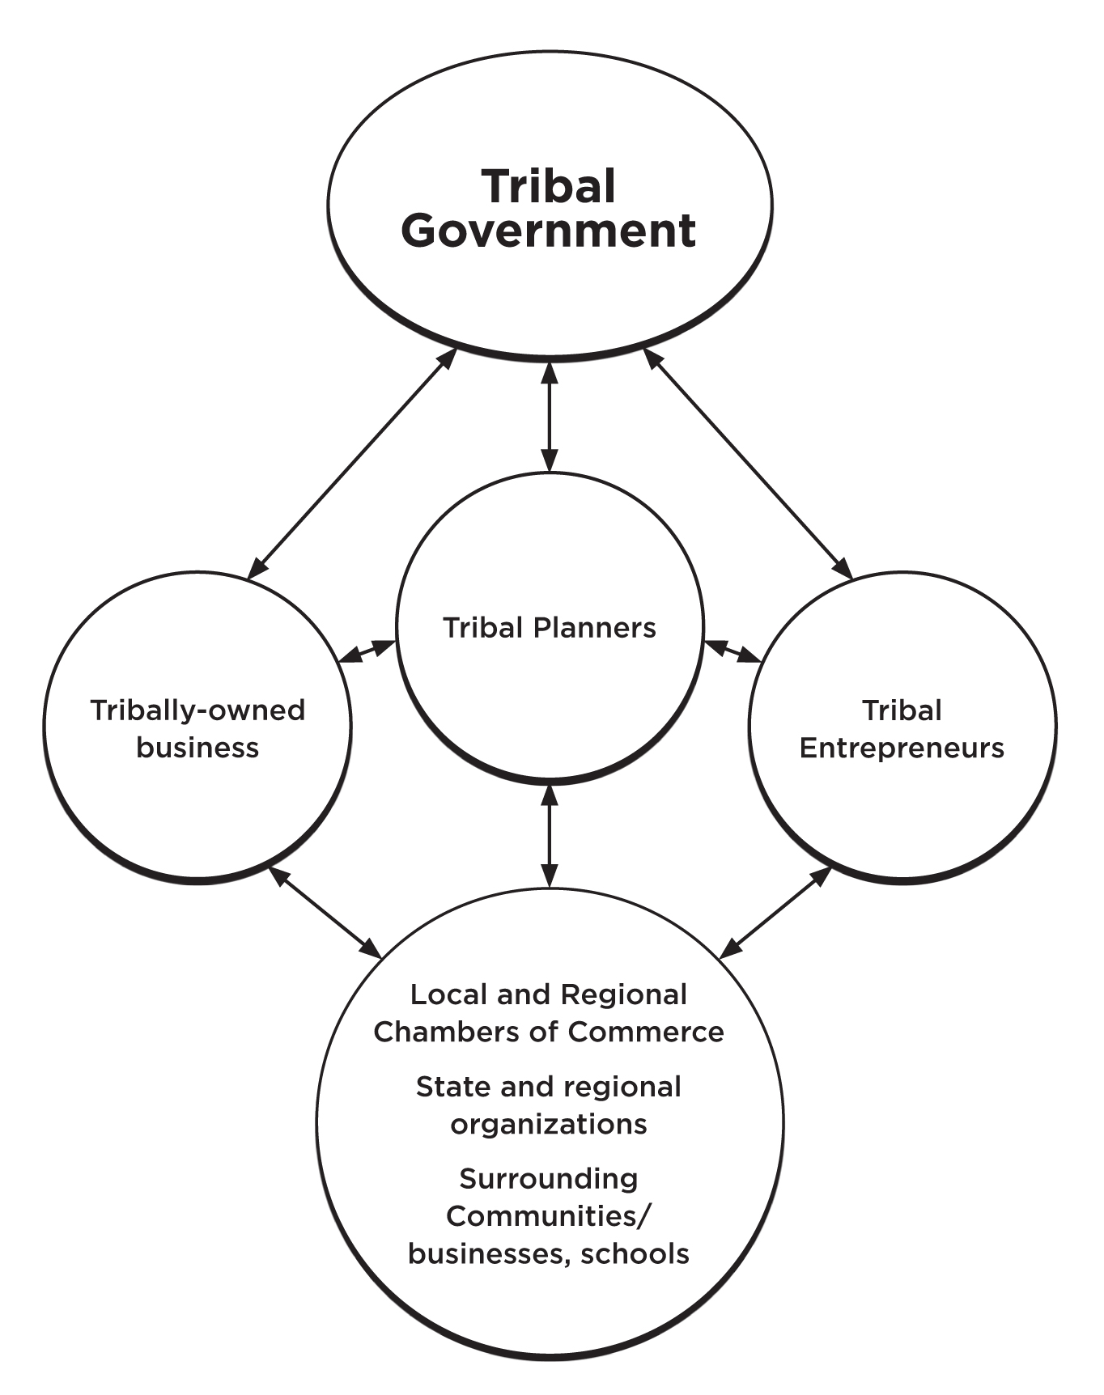
TRIBAL ECONOMY NETWORK

Diversified levels of business development are a key factor in community satisfaction. A frequent source of friction within a community occurs when tribal government planning addresses only larger-scale enterprises. A more diversified approach is inclusive of individual entrepreneurs and small businesses as well as larger businesses. Including the smaller-scale of service and supplier businesses strengthens a tourism system from within, creates jobs and increases economic multipliers. When businesses of different scales work together within a tourism system, the visitor experience becomes cohesive.
- THE TOURISM PLAN
The skills of listening, assessing, and discussing create a solid path for small-scale tourism. Throughout the planning process, the challenge is bridging from community expression to cultural interpretation—without becoming lost or overwhelmed with the details of assessment. Arriving at a unique experiential concept representing a culture is not an easy task, but rather one that requires careful attention to cultural views, hesitations, and boundaries for sharing.
Before generating ideas for new tourism projects, a first step is to identify existing activities, amenities and services. This is the community participation stage of the planning process. Gaining a thorough understanding of the current local tourism system is the first, and often overlooked, phase for community-based tourism.
Planning is a means of designing strategies to maximize the benefits of moving forward, while protecting resources. An inclusive planning process is central to identifying needs as well as opportunities, shaping future tourism programs and initiatives. Strategies for expanding the potential from tourism, cultural, artistic and financial—while protecting a community’s identity and historical resources, are central to the planning process.

An outline for the tourism plan sensitive to cultural concerns could include the following topics:
Executive Summary
I. Introduction
II. Location/ Regional Network Concept
- Community / Culture/ Values
- Community Profile/ Assessments
- The Tourism System
- Key Issues
VII. Tourism Readiness
VIII. Tourism Goals and Objectives
IX. Market Overview and Trends
- Strategies to Capture Market Share
- Needed Promotion
- Partnership Opportunities
- Developing Working Relationships with Tourism Partners
- Product Development
- The Transportation System
- Potential Environmental & Access Impacts/ Protections
- Funding Opportunities—Sources and Leveraging
- Personnel Scenarios for Managing Tourism
- Projects for Moving Ahead
- Recommended Phases, Steps and Development Timelines
- Tourism Program Operating Budget
Conclusion

A thorough analysis of the tourism system looks at both regional and local levels, with a community assessment seen within the context of the regional network. The outline above includes both levels.
- CONDUCTING A VISITOR SURVEY
“Where do they come from and what are they looking for?” These questions underscore the best match between visitor interests and what the tribal community offers. A well-designed visitor survey puts the power into effective tourism development and marketing. Knowing what visitors want is fundamental for developing a managed tourism program.
Understanding visitor preferences increases tourism benefits. When new business development matches visitor interest, visitation and jobs increase as well. Understanding of local history and culture expands also. To target a specific tourism market, local businesses must be responsive to visitor needs.
The majority of state and national visitor surveys collect data in urban areas, missing tribal and rural differences. A valuable exception is the international in-flight survey conducted by the U.S. Department of Commerce with travelers interested in tribal communities, posted on AIANTA’s website. Using data from two routes—urban survey results indicating potential visitors to draw to your community plus conducting a tribal community-specific survey—is useful for determining the right “cultural fit” between visitor interests and the desired direction of the community. Using both routes produces data that complement each other for tourism development.
The use of standard industry questionnaires by tourism entities frequently leads to a generalized—and sometimes not tribal community-relevant set of questions in a survey. Yet, standard demographic data from broader visitor surveys are valuable for attracting visitors to your community. Collaborating with regional and state tourism agencies to suggest culturally-based questions on their surveys yields a broader sample, often at no cost. Then, conducting a community-based survey targets business opportunities with tribal community-specific questions. Questions on visitor interest in tribal culture provide useful data for implementation of tribal visitor amenities, activities, lodging and food service that are compatible for the community.
A broad range of questions identifies basic demographic characteristics and visitor interests—useful for both tourism development and marketing. Tourism surveys identify the following:
- Visitor primary residence, or “point-of-origin;”
- Age of respondent;
- Source of information obtained for trip planning;
- Specific activities desired while staying with the community;
- Interest in historical interpretation;
- Topics for exhibits or demonstrations;
- Types of products desired;
- Where buying products currently;
- Planned spending on products and services;
- Specific tours;
- Lodging type;
- Food choices—especially cultural;
- Household income;
- Satisfaction rating on local businesses and activities; and
- Suggestions for improvement.

A sample cultural tourism visitor survey for Indian Country follows.

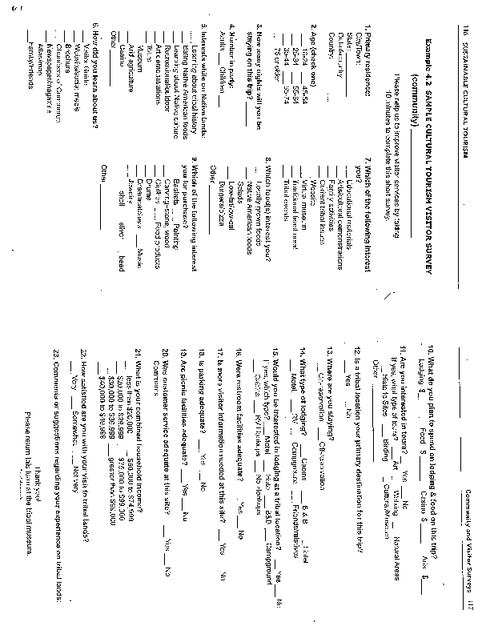

- CREATING JOBS

The concept of a “product” tends to be a culturally sensitive issue. The tourism industry widely refers to a product as a tour to book, or as an object to be sold. In traditional communities, there are many cultural boundaries concerning both items and information about the use of these items. Ultimately, each community must make its own decisions based on tradition, values, and the need for livelihood.

Economic multipliers increase in a locale as additional products are made within the region, rather than imported. The challenge is finding the intersection between a cultural fit with the community that also meshes well with the broader industry. Referrals to a community’s businesses are directly related to income and jobs.
A basic interpretation of the tour package concept is a self-guided tour. How does the visitor learn about a self-guided tour? Visitors find local interests by picking up a brochure in an urban area, through a website, social media, or in a visitor guide—in addition to the word-of-mouth referral visitors.
Cultural tourists are seeking information about the artist, as well as authenticity of materials and the art making process.

In the small-scale sense, there is another concept of product, significant in a cultural way—selling cultural items with respect so as not to commodify cultural meaning. Opportunities for entrepreneurs include the cultural arts: jewelry, baskets, pottery, textiles, beadwork, carvings, and food products as well as smaller scale tours and guide services.
Targeting a market or several markets increases the potential for sales in several ways. Admissions, lodging, and food service comprise a segment of potential sales. Art items, souvenirs, and packaged local foods are all opportunity niches. Food service focusing on regional specialties ranks high in visitor appeal.
To understand differences in urban and rural tastes, ask visitors about their food preferences. This is the best way to tailor a menu to the visitor profile, either through a visitor survey or customer comments. A range of options, from traditional foods for the adventurous to mainstream food choices, will best match visitor preferences. Most cultural travelers are from urban areas, have disposable income, and seek a new experience.
By providing training and advertising support to local entrepreneurs, the amount of earned livelihood created through entrepreneurial activities is multiplied many times beyond the basic tourism amenities. Both are complementary and draw visitors for the culturally-based vacation. The hand-made item and traditionally based service draws visitors initially, building a market for the larger amenity businesses. As internal community capacity and the range of amenities grows—then a complete vacation concept develops and length-of-stay increases. Additional expenditures and jobs reflect the potential for an upward spiral supporting local livelihood.
Product development suitable for entrepreneurs, interpreted as a range of services and cultural items, includes:
- Art items;
- Souvenir lines;
- Food products;
- Organizing guide services;
- Specific tours—cultural, agricultural, ecological, hunting & fishing;
- Entrepreneurial food services; and
- Small-scale lodging, such as bed and breakfasts, cabins and campgrounds.
Maintaining a variety mix of products and representing a range in pricing, attracts visitors. The souvenir line generates the majority of sales and is generally considered to be items costing $25 (USA) or less. The mid-price and upper-end relate primarily to the cultural arts and depend upon the local region and culture.

Entrepreneurial Topics to Include
This section suggests a place to start with business training, as well as curriculum content. Courses effectively begin at the entrepreneurial level and then build to the storefront business, from the home cottage industry to a formal business setting. Avoiding “canned” training packages geared to large scale tourism businesses and not tailored to local culture helps avoid a cultural skew.
Unfortunately, most textbooks on the subject are intended for the profit-motive cultural orientation, rather than a broad range of community values. Local college staff may be a training resource, offering course credit as well—if local businesses collaborate on the design of the training to ensure inclusion of cultural values and in-depth experience with the local market.
In my experience working with traditional artists, there are several different levels of entrepreneurial capabilities. For example, at least five tracks for artist business training are possible.
1) A workshop for artists enrolled in traditional arts training, who desire business skills to earn supplemental income;

2) An artist intensive for those students taking several courses in one or more art with the intention of earning a full-time living;

3) Workshops for artists with selling experience who desire to upgrade their business skills;

4) Topics for the experienced businessperson who may conduct sales for the family; and

5) A workshop series for the storefront gallery business.

Significant training topics for an artist entrepreneurial program include: focusing the business idea; assessing the market; identifying qualifications; the mini-business plan; creating the bio-card with artist information; financial record keeping; taxes; vending, art shows; evaluating success and redirecting efforts.
Topics effective for a food service training cover: general food preparation; traditional food preparation and interpretation; food handling and storage; the work environment; safety practices (lifting and carrying); welcoming customers; taking orders at tables; appropriate clothing; opening/closing; cash register procedures and operation.
Topics for a tour guide training include: cultural history; natural history; cultural considerations for privacy; code of ethics for guides and travelers; customer service; leadership and conflict resolution skills; equipment operation; safety and survival techniques; first aid; and business skills for managers.
Since entrepreneurs tend to listen first to other entrepreneurs, guest speakers with visible success contribute to a thriving entrepreneurial program. Organizing field trips to nearby places that sell to tourists is a valuable way for cultural entrepreneurs to learn which items are selling well, how displays are created, and ways of delivering customer service in a local manner. Observing and then critiquing in class assists students in making decisions regarding their products and livelihood.
Consistency in the delivery of a service or product is central to training for the tourism market. For example, if store hours are advertised, then provide coverage during those hours. Otherwise, a frustrated tourist will not return. In contrast, a satisfied customer will rapidly spread the word about a good business or product. An entrepreneur operating from the home must be consistent in answering messages or filling orders, in order to maintain that most economical referral means of marketing. Being friendly and interactive toward customers creates mutual satisfaction in business.

Mentoring Programs

Pairing experienced entrepreneurs through mentoring, with those beginning to learn skills, is an excellent way to provide practical experience. Although sharing information within a particular culture may be the traditional way of learning, participation in a cash economy through tourism sometimes skews traditional ways of learning, particularly if competition for sales is sensed. Or, the experienced entrepreneur may not be willing to commit the time required to be a mentor.
There are several ways to work with culture if this happens. Offering perks—or benefits for the experienced entrepreneur—such as assistance with marketing or participation in a booth at an outdoor market or art show, encourages mentoring. Including booth space for family members encourages an intergenerational incentive.
Some cultures discuss a spiritual obligation to teach and continue traditions. Looking within cultural ways of teaching fosters traditional ways of mentoring.

Authenticity Issues

What is the boundary between sharing culture and over-commercialization of tradition? This question is at the root of authenticity issues. To not exploit culture, yet to share; to sell, yet not change tradition; to give some information, yet respect cultural boundaries—these are the challenges of maintaining authenticity of both cultural arts and experience. Cultural arts are constantly evolving. Past, present and future are considerations for traditional cultures, as a circle of continuity.
Cultural sharing, in an ideal world, would not involve a monetary exchange. Yet the reality of community and family needs, where some movement into cash economies is complemented with subsistence activities and barter, indicates the necessity for balance in sustainable development. A proactive approach toward tourism and increased awareness of alternatives in communities enables options for engaging in tourism in a way that an agrarian lifestyle or traditional economic activities—such as hunting, fishing, and gathering—are still practiced. Using the concept of multiple income streams leads to flexibility.

Factors basic to the authenticity of cultural arts are: ethnicity, materials, techniques, cultural accuracy, quality, and heritage connections. Visitors are seeking the work of local artists, traditional methods, the stories connected to the arts, as well as traditional materials and designs—the authentic. There is an ongoing debate in the field of tourism on the meaning of authenticity. Does tourism impact, negatively or positively, the authenticity of a culture?
A productive and realistic view is to shift the focus to community response, encouraging internal discussions on authenticity decisions, and increasing access to community-based training implemented according to these decisions. What is needed from technical assistance providers is a highly developed capacity to listen, the primary way of communicating information in traditional cultures.
Maintaining authenticity requires careful consideration by a community. For example, plant knowledge shared in detail sometimes results in the stripping of forest resources—severely impacting art-making, healing, and food gathering practices. Clay resources for pottery or trees for basketry may likewise be depleted. Environmentally sound gathering practices involve an insightful knowledge of the plant and how to harvest without depletion or damage, and even how to harvest with stewardship, contributing to the thriving of the plant.

- EVALUATING SUCCESS
Sustainability, in essence, is about interdependence. Balance in cultural, economic, and ecological relationships is central for maintaining harmony. And hospitality—sharing food, appropriate information, and cultural arts—coming from a genuine respect for tradition, indicates the wise use of resources.

Sustainable Tourism Management Assessment
Assess the community’s tourism development progress on a scale
of 1 to 5, with a 5 as the higher rank.

Development | Low |  |  |  | High
Tourism plan completed  Clear vision/goals/assessment resources | 1 | 2 | 3 | 4 | 5
Visible point/ intake center for entering the community | 1 | 2 | 3 | 4 | 5
Community welcome visible | 1 | 2 | 3 | 4 | 5
Provide information/ cultural history | 1 | 2 | 3 | 4 | 5
Signage clear | 1 | 2 | 3 | 4 | 5
Environmental impacts assessed | 1 | 2 | 3 | 4 | 5
Consistent with land use plan | 1 | 2 | 3 | 4 | 5
Transportation plan in place | 1 | 2 | 3 | 4 | 5
Micro-loans available | 1 | 2 | 3 | 4 | 5
Product development assistance | 1 | 2 | 3 | 4 | 5
Assistance with tourism business plans | 1 | 2 | 3 | 4 | 5
Management | Low |  |  |  | High
Staff time allocated for managing tourism | 1 | 2 | 3 | 4 | 5
Visitor etiquette readily available | 1 | 2 | 3 | 4 | 5
Visitor’s survey conducted (know interests) | 1 | 2 | 3 | 4 | 5
Method for counting visitors | 1 | 2 | 3 | 4 | 5
Restrooms adequate and clean | 1 | 2 | 3 | 4 | 5
Food service interesting and efficient | 1 | 2 | 3 | 4 | 5
Lodging interesting and reliable | 1 | 2 | 3 | 4 | 5
Community members trained to give directions | 1 | 2 | 3 | 4 | 5
Training available for businesses | 1 | 2 | 3 | 4 | 5
Training available for entrepreneurs | 1 | 2 | 3 | 4 | 5
Tours available | 1 | 2 | 3 | 4 | 5
Community satisfaction assessed annually | 1 | 2 | 3 | 4 | 5
Visitor satisfaction assessed annually | 1 | 2 | 3 | 4 | 5
Adequate water & sewage | 1 | 2 | 3 | 4 | 5
Regular trash collection | 1 | 2 | 3 | 4 | 5
Eco-system restoration | 1 | 2 | 3 | 4 | 5
Improvements made annually/ redirect | 1 | 2 | 3 | 4 | 5
Promotion | High |  |  |  | Low
Maps available of community and businesses | 1 | 2 | 3 | 4 | 5
Vacation itineraries developed, detailing local offerings | 1 | 2 | 3 | 4 | 5
All scales of business - small, entrepreneurial, larger included | 1 | 2 | 3 | 4 | 5
Partnering with other communities for an effective referral network | 1 | 2 | 3 | 4 | 5
Linkages established to surrounding communities | 1 | 2 | 3 | 4 | 5

As an approximate guideline, scores below a 2.5 average indicate a tourism effort in need of redirection, between 2.5 and 3.5 need improvement and re-examination of sustainable strategy; from 3.6 to 4.5 are on the sustainable path and need to keep improving; and above 4.5 are excellent in sustainable implementation. By assessing, evaluating, and redirecting, negative impacts are likely to be reduced and positive benefits increased.

