Travel Guide to Tribal Nations Along the Juan Bautista de Anza National Historic Trail

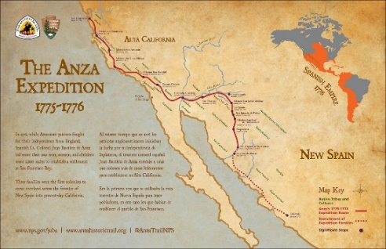
In a one-of-a-kind partnership with the National Park Service, AIANTA is chronicling the attractions and businesses of the tribes located on or near the Anza Trail. The three-year partnership will culminate in a print/online guidebook reflecting tribal attractions at key spots along the Trail, and a first-of-its kind map, that will translate key locations along the Trail back in the original native languages.

About the Anza Trail
Administered by the National Park Service, the Juan Bautista de Anza National Historic Trail connects history, culture and outdoor recreation along a 1,200-mile corridor from Nogales, Arizona, to the San Francisco Bay Area. In 2018, the National Park Service celebrated the 50th anniversary of the National Trails System Act, including the Anza Trail.

Steve Larese, Travel Writer
Steve Larese develops and writes articles and completes photo and video assignments for print, online and social media for a wide range of clients on tight deadlines including Travel Channel, National Geographic Traveler, American Way, Interval World Magazine, New Mexico Journey, VIE Magazine, BBC Travel, Forbes Travel, ShermansTravel.com, U.S News & World Report, Southwest Fly Fishing, Men’s Journal, USA Today, Arizona Highways, Rizzoli Books, Schiffer Publishing, Farcountry Press and other national periodicals and books. (505) 331-8358 cell/text, stevelarese@gmail.com

Dr. Margaret Pearce, Cartographer
Margaret Pearce is Citizen Band Potawatomi and a cartographer and writer. She grew up on Seneca territory at Ga’sgöhsagöh (Rochester, NY) and these days is grateful to be a guest on Penobscot territory at Catawamkeag (Rockland, Maine). Her maps have been exhibited nationally and internationally and include Coming Home to Indigenous Place Names in Canada (2017); Iyoka Eli-Wihtamakw Kǝtahkinawal / This Is How We Name Our Lands (2015); They Would Not Take Me There: People Places and Stories from Champlain's Travels in Canada, 1603–1616 (2008); and The Intricacy of These Turns & Windings: A Voyageur's Map (2005). (740) 590-9978 cell/text, margaret@studio1to1.net

About AIANTA
For nearly two decades, the American Indian Alaska Native Tourism Association (AIANTA) has served as the national voice for American Indian nations engaged in cultural tourism. In addition, AIANTA provides technical assistance, training and capacity building to Tribal nations and Native-owned enterprises engaged in tourism, hospitality and recreation.

AIANTA Tribal Relations Team

Gail E. Chehak, Tribal Relations and Outreach Manager
505.243.3633 direct, 505.417.1143 cell/text, gchehak@aianta.org

Lorraine Gala Lewis, Research and Outreach Specialist
505.738.7214, ext. 1000 direct, llewis@aianta.org

Bruce Rettig, Tribal Content Developer
530-577-2005; brettig@aianta.org

